Lagged cross-correlation: AUDUSD and NZDUSD
Method 12 / daily log returns / K_max=10 / Alpari D1 full available history

Study setup
Logical pair: AUDUSD , NZDUSD
Broker symbols: AUDUSD_i , NZDUSD_i
Snapshot: 2026-11-03_majors_alpari_D1
Timeframe: D1
Matched return window: 1999-01-05 to 2026-11-02 (UTC bar dates)
Matched return count n: 7202
Dropped unfinished last bar dated 2026-11-03 UTC after a tick-volume check against the prior complete day.
Lag definition: rho_X->Y(k) = Corr(x_t, y_{t+k}) on matched D1 bars
K_max = 10; headline lag k = 1 (both directions)
Complete matched rows (Excel): AUDUSD-NZDUSD_Lagged_D1.xlsx
Complete matched rows (HTML table): AUDUSD-NZDUSD_Lagged_D1_data.html

Method carried forward
Lagged cross-correlation measures Pearson correlation between matched daily log returns of close, ln(close_t / close_t-1), after shifting one series forward by k bars on the matched panel. Quotes are not inverted. rho_{X->Y}(k) = Corr(x_t, y_{t+k}) with n_k = n - k. K_max = 10 is fixed before estimation. The headline is the pre-specified lag k = 1 in both directions. k = 0 is the same-bar side check. The lag inside 1..10 with the largest absolute rho is stored as a descriptive column only; it is not a selected result. This is a linear screen, not proof of forecast edge, economic cause, or a trading signal.

Results (headline k=1)
rho_AUDUSD->NZDUSD(1): -0.009668 (n=7201)
95% Fisher interval AUDUSD->NZDUSD: [-0.032758, 0.013432]
rho_NZDUSD->AUDUSD(1): -0.038993 (n=7201)
95% Fisher interval NZDUSD->AUDUSD: [-0.062035, -0.015910]
Same-bar rho(k=0): 0.828722
Largest |rho| among k=1..10 (descriptive only, not selected): AUDUSD->NZDUSD k=9 rho=-0.039392; NZDUSD->AUDUSD k=1 rho=-0.038993

CCF table
k | rho_AUDUSD_to_NZDUSD | n_AUDUSD_to_NZDUSD | rho_NZDUSD_to_AUDUSD | n_NZDUSD_to_AUDUSD
0 | 0.82872182 | 7202 | 0.82872182 | 7202
1 | -0.00966811 | 7201 | -0.03899332 | 7201
2 | 0.00225408 | 7200 | -0.0050702 | 7200
3 | -0.0077188 | 7199 | -0.01638244 | 7199
4 | 0.01731595 | 7198 | 0.03033651 | 7198
5 | -0.01213183 | 7197 | -0.01625303 | 7197
6 | -0.02781857 | 7196 | -0.03620701 | 7196
7 | 0.01209801 | 7195 | 0.00224914 | 7195
8 | 0.02096817 | 7194 | 0.01074626 | 7194
9 | -0.0393917 | 7193 | -0.01338923 | 7193
10 | 0.01551266 | 7192 | -0.00416691 | 7192

Conclusion
At the pre-specified lag k=1 for AUDUSD and NZDUSD, rho_{AUDUSD->NZDUSD}(1) = -0.0097 (n=7201) and rho_{NZDUSD->AUDUSD}(1) = -0.0390 (n=7201). Same-bar rho(k=0) = 0.8287. Largest |rho| among k=1..10 is descriptive only: AUDUSD->NZDUSD at k=9 (-0.0394); NZDUSD->AUDUSD at k=1 (-0.0390). This is a linear screen, not forecast proof or a trading signal.

Charts
Daily closes

Daily log returns

CCF both directions k=0..10
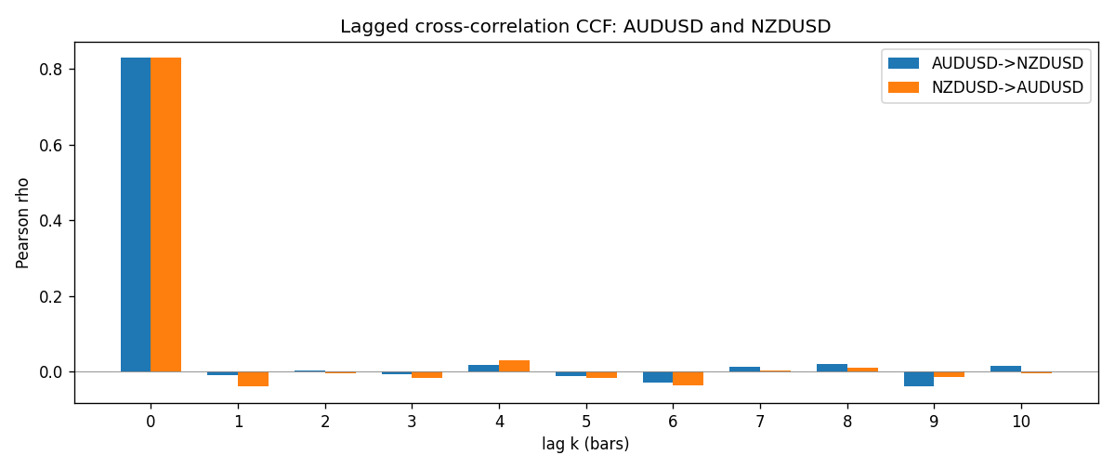

Data report
Every matched row is stored in the sibling Excel workbook named AUDUSD-NZDUSD_Lagged_D1.xlsx (sheet matched_rows). The CCF sheet holds rho(k) for k=0..10. Embedding all rows as a Word table is impractical; the Word file holds column summaries and the first and last 15 rows.
Columns: time, AUDUSD_open, NZDUSD_open, AUDUSD_high, NZDUSD_high, AUDUSD_low, NZDUSD_low, AUDUSD_close, NZDUSD_close, AUDUSD_tick_volume, NZDUSD_tick_volume, AUDUSD_spread, NZDUSD_spread, AUDUSD_real_volume, NZDUSD_real_volume, AUDUSD_log_return, NZDUSD_log_return
Column summaries (matched calculation rows)
column | count | mean | std | min | 25% | 50% | 75% | max
AUDUSD_open | 7202 | 0.75190973 | 0.13530408 | 0.4785 | 0.6610275 | 0.731395 | 0.8089525 | 1.10284
NZDUSD_open | 7202 | 0.65620671 | 0.10825448 | 0.3913 | 0.5910925 | 0.6683 | 0.724695 | 0.88218
AUDUSD_high | 7202 | 0.75595988 | 0.13586572 | 0.4878 | 0.6647 | 0.734725 | 0.81501 | 1.10795
NZDUSD_high | 7202 | 0.66012182 | 0.1087492 | 0.3961 | 0.5946275 | 0.67189 | 0.7292675 | 0.88421
AUDUSD_low | 7202 | 0.74785283 | 0.13461673 | 0.4775 | 0.6577 | 0.727385 | 0.8042 | 1.0975
NZDUSD_low | 7202 | 0.6525168 | 0.10784895 | 0.3897 | 0.587955 | 0.66406 | 0.72082 | 0.87988
AUDUSD_close | 7202 | 0.75195766 | 0.13528533 | 0.4786 | 0.6611925 | 0.731645 | 0.809065 | 1.10169
NZDUSD_close | 7202 | 0.65627751 | 0.10825012 | 0.3907 | 0.59141 | 0.668305 | 0.7249175 | 0.8822
AUDUSD_tick_volume | 7202 | 77337.3 | 138128.78 | 109 | 5435.5 | 43320 | 71312.25 | 1234623
NZDUSD_tick_volume | 7202 | 68561.899 | 123036.41 | 17 | 5505.5 | 33822 | 58470.25 | 1127682
AUDUSD_spread | 7202 | 30.821161 | 16.887481 | 0 | 13 | 30 | 50 | 50
NZDUSD_spread | 7202 | 30.366287 | 25.672101 | 0 | 9 | 17 | 50 | 80
AUDUSD_real_volume | 7202 | 5.2413627e+09 | 1.253718e+11 | 0 | 0 | 0 | 0 | 3.811512e+12
NZDUSD_real_volume | 7202 | 1.6659405e+10 | 8.488719e+10 | 0 | 0 | 0 | 0 | 2.705649e+12
AUDUSD_log_return | 7202 | 2.237e-05 | 0.00754318 | -0.08602525 | -0.00386318 | 0.00028132 | 0.00415217 | 0.0806166
NZDUSD_log_return | 7202 | 5.13e-06 | 0.00764596 | -0.07027433 | -0.00426304 | 0.00021271 | 0.00457975 | 0.05966839
First 15 matched rows (selected columns)
time | AUDUSD_close | NZDUSD_close | AUDUSD_log_return | NZDUSD_log_return
1999-01-05 | 0.6215 | 0.5372 | -0.00080418179 | -0.0018597736
1999-01-06 | 0.6289 | 0.5383 | 0.011836351 | 0.0020455609
1999-01-07 | 0.6345 | 0.5417 | 0.0088650256 | 0.0062963171
1999-01-08 | 0.6347 | 0.5414 | 0.00031515916 | -0.00055396548
1999-01-11 | 0.6393 | 0.547 | 0.0072213815 | 0.010290425
1999-01-12 | 0.6362 | 0.5441 | -0.0048608485 | -0.0053157489
1999-01-13 | 0.6312 | 0.5387 | -0.0078902098 | -0.0099742238
1999-01-14 | 0.6295 | 0.5386 | -0.002696916 | -0.00018564931
1999-01-15 | 0.634 | 0.5382 | 0.007123101 | -0.00074294208
1999-01-18 | 0.6346 | 0.5372 | 0.00094592471 | -0.0018597736
1999-01-19 | 0.6392 | 0.5382 | 0.0072225153 | 0.0018597736
1999-01-20 | 0.64 | 0.5404 | 0.0012507819 | 0.0040793678
1999-01-21 | 0.6405 | 0.5426 | 0.00078094498 | 0.0040627941
1999-01-22 | 0.6327 | 0.5361 | -0.012252745 | -0.012051689
1999-01-25 | 0.6302 | 0.5342 | -0.0039591468 | -0.0035504102
Last 15 matched rows (selected columns)
time | AUDUSD_close | NZDUSD_close | AUDUSD_log_return | NZDUSD_log_return
2026-10-13 | 0.69821 | 0.56127 | 0.0035007712 | 0.0047326165
2026-10-14 | 0.69715 | 0.55918 | -0.0015193215 | -0.0037306483
2026-10-15 | 0.69191 | 0.56185 | -0.0075447063 | 0.0047634855
2026-10-16 | 0.69426 | 0.56509 | 0.0033906408 | 0.0057501001
2026-10-19 | 0.6978 | 0.56616 | 0.0050859986 | 0.0018917133
2026-10-20 | 0.70022 | 0.56827 | 0.0034620426 | 0.0037199341
2026-10-21 | 0.70275 | 0.57003 | 0.0036066384 | 0.0030923331
2026-10-22 | 0.70186 | 0.56815 | -0.0012672558 | -0.0033035227
2026-10-23 | 0.70353 | 0.56991 | 0.0023765656 | 0.0030929853
2026-10-26 | 0.70128 | 0.56826 | -0.0032032829 | -0.0028993932
2026-10-27 | 0.70245 | 0.56811 | 0.0016669876 | -0.00026399852
2026-10-28 | 0.70533 | 0.56261 | 0.0040915541 | -0.0097283914
2026-10-29 | 0.70245 | 0.56296 | -0.0040915541 | 0.00062190714
2026-10-30 | 0.70316 | 0.56307 | 0.0010102376 | 0.00019537668
2026-11-02 | 0.69971 | 0.56161 | -0.0049184984 | -0.0025962955

